STOCHASTIC PROCESS LAB FILE



Submitted to: Dr. H.C. Taneja

Submitted by: Ashish Srivastav

2K17/MC/024

|  |  |  |  |
| --- | --- | --- | --- |
| SNO  . | EXPERIMENT | DATE | SIGNATURE |
| 1. | Simulation of discrete parameter stochastic processes |  |  |
| 2. | Simulation of continuous parameter stochastic processes |  |  |
| 3. | Homogeneous and Non-Homogenous Bernoulli Process |  |  |
| 4. | Homogenous, Non-Homogenous Poisson Process and Renewal Process with Uniform Distribution |  |  |
| 5. | Simple Random Walk (Unrestricted) |  |  |
| 6. | Random walk with absorbing barriers |  |  |
| 7. | Random walk using Markov chains (absorbing and reflecting barriers) |  |  |
| 8. | Ergodic chain Steady state probabilities |  |  |
| 9. | M/M/1 Queuing Model |  |  |

EXPERIMENT # 1

**QUESTION:** Simulate the following discrete parameter stochastic processes

1. Discrete State Space: Outcomes of Nth toss of the fair dice.
2. Continuous State Space: Average time taken for clothes to be washed on nth day of month given time required is 2 minutes and maximum time taken is 4minutes.

**THEORY:**

**RANDOM PROCESS (OR STOCHASTIC PROCESS):**

In many real-life situations, observations are made over a period of time and they are influenced by random effects, not just at a single instant but throughout the entire interval of time or sequence of times. In a “rough” sense, a random process is a phenomenon that varies to some degree unpredictably as time goes on. If we observed an entire time-sequence of the process on several different occasions, under presumably “identical” conditions, the resulting observation sequences, in general, would be different. A random variable (RV) is a rule (or function) that assigns a real number to every outcome of a random experiment, while a random process is a rule (or function) that assigns a time function to every outcome of a random experiment.

**Definition:** A random process(or STOCHASTIC PROCESS) is a collection (or ensemble) of RVs { X (s, t ) } that are functions of a real variable, namely time t where s ∈ S (sample space) and t ∈ T (parameter set or index set).

# CODE:

1. Discrete Parameter Discrete State Space –

x = [1:1:30];

y = randi ([0 6],30,1);

p = scatter(x,y);

xlabel('ith toss of a fair dice');

ylabel ('outcome of the Nth toss ');

title ('Discrete Parameter - Discrete State Space');

1. Discrete Parameter Continuous State Space –

x = [1:1:30];

y = 120 + 120.*rand(30,1);

p = scatter(x,y); xlabel('Days of Month');

ylabel('Avg Time Taken for Clothes Wash');

title('Discrete Parameter - Continuous State Space');

# OUTPUT:

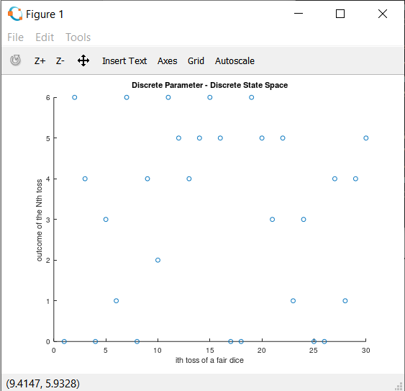

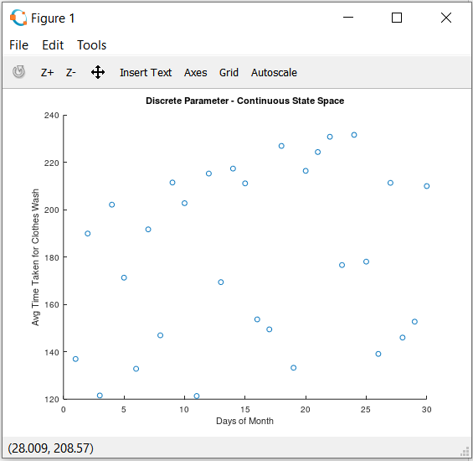

EXPERIMENT # 2

**QUESTION:** Simulate the following continuous parameter stochastic processes –

1. Discrete State Space: Number of months temperature changed in Delhi in 2 years with maximum change of 10 times.
2. Continuous State Space: variation of temperature between 20-40 degrees(in Celsius) in Delhi in 2 years

**Theory:**

The distinction between a stochastic process and a sample path of that process is important. We can derive statements about how a process will behave from a stochastic process model. A sample path is a record of how a process actually did behave in one instance. Sample paths are generated by executing algorithm simulation with speciﬁc seeds or streams for the pseudorandom-number generator.

A sample path is a collection of time-ordered data describing what happened to a dynamic process in one instance. A stochastic process is a probability model describing a collection of time-ordered random variables that represent the possible sample paths.

CONTINUOUS PARAMETER:

In [probability theory](https://en.wikipedia.org/wiki/Probability_theory), a continuous stochastic process is a type of [stochastic process](https://en.wikipedia.org/wiki/Stochastic_process) that may be said to be "[continuous](https://en.wikipedia.org/wiki/Continuous_function)" as a function of its "time" or index parameter. Continuity is a nice property for (the sample paths of) a process to have, since it implies that they are [well-behaved](https://en.wikipedia.org/wiki/Well-behaved) in some sense, and, therefore, much easier to analyze. It is implicit here that the index of the stochastic process is a continuous variable.

CODE:

1. Discrete State Space:

X = [0:0.2:24];

Y = randi([0 10],121,1);

Plot = stairs(X,Y);

xlabel('Time in months');

ylabel('No. of times the Temperature changed in Delhi');

title('Continuous Parameter – Discrete State Space');

1. Continuous State Space:

X = [0.01:0.1:2];

Y = 20 + 20.*randi([0 10],20,1);

plot(X,Y);

xlabel('Time in years');

ylabel('Temperature Change in Delhi (in degree Celsius)');

title('Continuous Parameter - Continuous State Space');

**OUTPUT:**

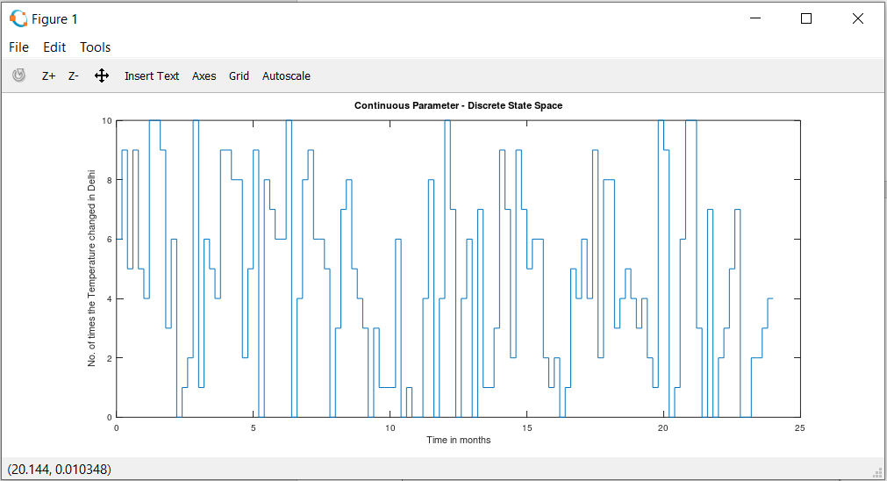

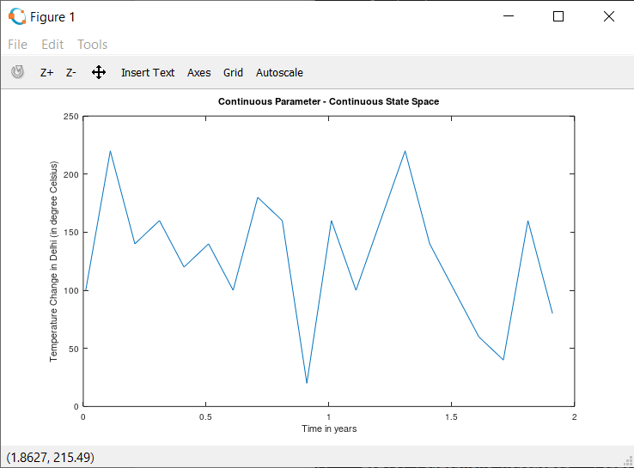

**EXPERIMENT #3**

**QUESTION:**

1. Write a program to find the probability of k success in a Bernoulli process with parameters n and p.

A bag contains 6 red marbles and 4 blue marbles. A marble is drawn at random from the bag, its color is noted and then it is replaced. Five marbles are drawn from the urn in this way (with replacement) and the number of red marbles is observed. Getting a red ball is success.

Find probability of getting 4 red balls in 10 trials.

1. Write a program to find the no of failures preceding first success in case of Bernoulli Process with parameter n and p.

A bag contains 6 red marbles and 4 blue marbles. A marble is drawn at random from the bag, its color is noted and then it is replaced. Five marbles are drawn from the urn in this way (with replacement) and the number of red marbles is observed. Getting a red ball is success. Find probability of getting 2 blue ball before getting first red ball.

**THEORY:**

The Bernoulli Process is an example of a discrete-parameter discrete-state process. Suppose Xi, i=1, 2,…,n are independent and identically distributed Bernoulli random variables each with probability p of success, that is, P{Xi =1} = p, and probability 1-p of failure, that is, P{Xi=0} = 1 – p. Let Sn = X1 + X2 +…+Xn be the number of successes in n Bernoulli trials. Then {Sn,n =1,2,…} is called Bernoulli process with state space {0, 1, 2, …}, and so is a discrete-parameter discrete-state process.

For each n, Sn has a binomial distribution with parameters n and p, and

P{Sn=k} = nCkpk(1-p)n-k, k =0,1,2,…n.

Starting at any particular Bernoulli trial, the number of failures F before the next success has a geometric distribution, that is,

P(F=k) = (1-p)kp, k=0, 1, 2, …

In each case of the Bernoulli variate Xi has the distinct parameter pi then the Bernoulli process is called a non-homogenous Bernoulli process.

**CODE:**

1. %x = 4 and n =10

function [prob] = bernoulli(x,n)

p = 0.6;

q = 1-p;

prob = 0;

for i=x+1:n

prob = prob + (factorial(n)/(factorial(n- i)*factorial(i)))*(p^i)*(q^(n-i));

end

end

1. %x=2 and n =10

function [prob] = nbernoulli(x,n)

prob = 0;

p=1; q=1;

for i=x+1:n

for j=1:i

p = p*(0.4*j);

end

for j=i+1:n

q = q*(1-(0.4*j));

end

prob = prob + (factorial(n)/(factorial(n-i)*factorial(i)))*p*q;

p=1;

q=1;

end

end

**OUTPUT:**

1. bernoulli(4,10)

ans = 0.83376

1. **ans = 0.0065033**

**EXPERIMENT # 4**

**QUESTION:**

1. Write a program to find the probability for the specific number of arrivals in time interval of length t, in case of Poisson process with rate λ>0.

The number of customers arriving at a grocery store can be modeled by a Poisson process with intensity λ=10 customers per hour. Find the probability that there are 22 customers between 10:00 and 10:20.

1. Write a program to find the probability for n deaths in a interval (0,t] in case of pure death process with rate µ>0.
2. Write the program to find the probability that in steady state, the system is in state n, in case of birth and death process when the rates depends on the state of the system.

THEORY:

The Poisson process is one of the most widely-used counting processes. It is usually used in scenarios where we are counting the occurrences of certain events that appear to happen at a certain rate, but completely at random (without a certain structure). For example, suppose that from historical data, we know that earthquakes occur in a certain area with a rate of $2$ per month. Other than this information, the timings of earthquakes seem to be completely random. Thus, we conclude that the Poisson process might be a good model for earthquakes.

Let $\lambda>0$ be fixed. The counting process $\{N(t), t \in [0, \infty)\}$ is called a Poisson process with rates $\lambda$ if all the following conditions hold:

1. $N(0)=0$;
2. $N(t)$ has independent increments;
3. the number of arrivals in any interval of length $\tau>0$ has $Poisson(\lambda \tau)$ distribution.

**CODE:**



function [p] = poisson(param,n)

p = 0;

for i=0:n

p = p+((exp(-param)*((param)^i))/factorial(i));

end

end

2.

**OUTPUT:**

1. >>poisson(10,22)

ans = 0.99970

1. ans = npoisson(4,10)

ans = 0.4647

**EXPERIMENT #5**

**QUESTION:**

1. Write a program to find the n step transition probability in case of a markov chain.

Suppose that whether it rains today depends on the previous weather conditions only from the last two days and let,

P[if it rained for the past two days, then it will rain tomorrow]= 0.7

P[if it rained today but not yesterday, then it will rain tomorrow]=0.5

P[if it rained yesterday but not today, then it will rain tomorrow]=0.4

P[if it has not rained past two days, then it will rain tomorrow]=0.2

Assuming the system to be homogenous, write it as markov chain. Let it rained on both Monday and Tuesday. What is the probability that it will rain on Thursday.

**THEORY:**

A Markov chain is a mathematical system that experiences transitions from one state to another according to certain [probabilistic](https://brilliant.org/wiki/probability-rule-of-product/) rules. The defining characteristic of a Markov chain is that no matter *how* the [process](https://brilliant.org/wiki/stochastic-processes/) arrived at its present state, the possible future states are fixed. In other words, the probability of transitioning to any particular state is dependent solely on the current state and time elapsed. The state space, or set of all possible states, can be anything: letters, numbers, weather conditions, baseball scores, or stock performances.

Markov chains may be modeled by [finite state machines](https://brilliant.org/wiki/finite-state-machines/), and [random walks](https://brilliant.org/wiki/the-random-walk/) provide a prolific example of their usefulness in mathematics. They arise broadly in [statistical](https://brilliant.org/wiki/statistics/) and [information-theoretical](https://brilliant.org/wiki/entropy-information-theory/) contexts and are widely employed in [economics](https://brilliant.org/economics/quantitative-finance/?subtopic=derivatives-2), [game theory](https://brilliant.org/wiki/game-theory/), [queueing (communication) theory](https://brilliant.org/wiki/queues-basic/), [genetics](https://brilliant.org/wiki/genetics/), and [finance](https://brilliant.org/economics/quantitative-finance/). While it is possible to discuss Markov chains with any size of state space, the initial theory and most applications are focused on cases with a finite (or countably infinite) number of states.

**CODE:**

n = input('Enter the value of step to be find ');

P =input('The TPM for one step markov chain ');

disp('The nth step TPM ');

disp(P^n);

**OUTPUT:**

>> markovian

Enter the value of step to be find 2

The TPM for one step markov chain [0.7 0.0 0.3 0.0;0.5 0.0 0.5 0.0;0.0 0.4 0.0 0.6;0.0 0.2 0.0 0.8]

The nth step TPM

0.49000 0.12000 0.21000 0.18000

0.35000 0.20000 0.15000 0.30000

0.20000 0.12000 0.20000 0.48000

0.10000 0.16000 0.10000 0.64000

Now, ATQ we want P(2)(0,0) and P(2)(0,1). Therefore , adding those two values = 0.4900 + 0.1200 =0.61

**EXPERIMENT #6**

**QUESTION:**

Write a program to find the renewal density m(t) in case of a renewal process where the inter renewal time is distributed with probability density f(t).

Specifically find m(t) when f(t) = 1/c 0<t<c.

**Theory:**

A renewal process is defined to be a discrete parameter independent process {Xn , n>=1}, where Xi are independent and identically distributed non negative random variable.

The function µ, given by µ(t) = H(t) + integral(o to t)( H(t − x)dm(x)), is a solution of the renewal-type equation. If H is bounded on finite intervals, then µ is bounded on finite intervals and is the unique solution of the renewal-type equation.

**CODE:**

syms f L IL L1 c t s;

c=input('Enter the value of C')

f = 1/c;

L1(t) = int(laplace(f,t));

L = L1/(c-L1);

IL = ilaplace(L,s,t);

disp("The function m(t) is : ");

disp(IL);

**OUTPUT:**

Enter the value of C 8

c =

8

The function m(t) is :

-(dirac(t)*log(t))/(log(t) - 64)

symbolic function inputs: t

**EXPERIMENT #7**

**QUESTION:**

1. Write a program to find the probability that in case of unrestricted simple random walk the particle is at position k at the nth step.
2. Write a program to find the probability that in case of a simple random walk the particle lies in one of the state between the position from j to k at nth step.(j<k)

THEORY:

A random walk is a mathematical object, known as a stochastic or random process, that describes a path that consists of a succession of random steps on some mathematical space such as the integers. An elementary example of a random walk is the random walk on the integer number line, Z , which starts at 0 and at each step moves +1 or −1 with equal probability. Other examples include the path traced by a molecule as it travels in a liquid or a gas, the search path of a foraging animal, the price of a fluctuating stock and the financial status of a gambler: all can be approximated by random walk models, even though they may not be truly random in reality. As illustrated by those examples, random walks have applications to engineering and many scientific fields including ecology, psychology, computer science, physics, chemistry, biology as well as economics. Random walks explain the observed behaviors of many processes in these fields, and thus serve as a fundamental model for the recorded stochastic activity.

A simple random (or unrestricted random walk) walk on a line or in one dimension occurs with probability p when walker step forward (+1) and/or has probability q=1−p if walker steps back (−1). For ith step, the modified Bernoulli random variable Wi (takes the value +1 or −1 instead of {0,1}) is observed and the position of the walk at the nth step can be found by

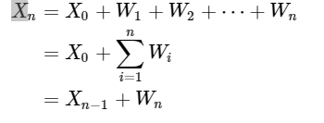

CODE:

function [p] = exp7(p,q,j,k,n);

if p+q < 1

r = 1- p - q;

c = 0.5;

else

c = 1;

end

mean = p - q;

sd = sqrt(p + q - (p-q)^2);

p = normcdf((k + c - n*mean)/(sd*sqrt(n))) - normcdf((j - c - n*mean)/(sd*sqrt(n)));

end

OUTPUT:

1. Taking p=0.4, q=0.6, and kth position 25 and n=100

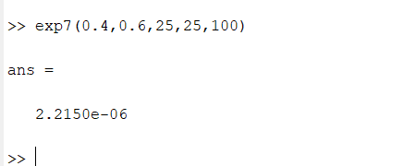

1. Taking p=0.7,q=0.3,and range between 15-40 and n=100

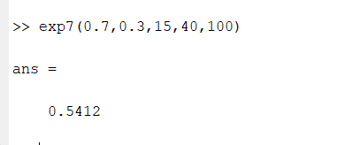

**EXPERIMENT #8**

**QUESTION:**

1) Write a program to find the probability that particle will get absorbed at one of the barrier at the nth stage in case of two barriers random walk.

Also to find the probability of absorption at one of the barrier.

2) Write a program to find the probability that in statistical equilibrium. The particle is found at one of the state in case of 2 reflecting surface.

**Theory:**

A random walk is a [mathematical](https://en.wikipedia.org/wiki/Mathematical) object, known as a stochastic or [random process](https://en.wikipedia.org/wiki/Random_process), that describes a path that consists of a succession of [random](https://en.wikipedia.org/wiki/Random) steps on some mathematical space such as the integers. An elementary example of a random walk is the random walk on the [integer](https://en.wikipedia.org/wiki/Integer) number line, which starts at 0 and at each step moves +1 or −1 with equal probability. Other examples include the path traced by a [molecule](https://en.wikipedia.org/wiki/Molecule) as it travels in a liquid or a gas, the search path of a [foraging](https://en.wikipedia.org/wiki/Foraging) animal, the price of a fluctuating [stock](https://en.wikipedia.org/wiki/Random_walk_hypothesis) and the financial status of a [gambler](https://en.wikipedia.org/wiki/Gambler): all can be approximated by random walk models, even though they may not be truly random in reality. As illustrated by those examples, random walks have applications to [engineering](https://en.wikipedia.org/wiki/Engineering) and many scientific fields including [ecology](https://en.wikipedia.org/wiki/Ecology), [psychology](https://en.wikipedia.org/wiki/Psychology), [computer science](https://en.wikipedia.org/wiki/Computer_science), [physics](https://en.wikipedia.org/wiki/Physics), [chemistry](https://en.wikipedia.org/wiki/Chemistry), [biology](https://en.wikipedia.org/wiki/Biology) as well as [economics](https://en.wikipedia.org/wiki/Economics). Random walks explain the observed behaviors of many processes in these fields, and thus serve as a fundamental [model](https://en.wikipedia.org/wiki/Statistical_model) for the recorded [stochastic activity](https://en.wikipedia.org/wiki/Stochastic_process). various types of random walks are of interest, which can differ in several ways. The term itself most often refers to a special category of [Markov chains or Markov processes](https://en.wikipedia.org/wiki/Markov_chain), but many time-dependent processes are referred to as random walks, with a modifier indicating their specific properties. Random walks (Markov or not) can also take place on a variety of spaces: commonly studied ones include [graphs](https://en.wikipedia.org/wiki/Graph_theory), others on the integers or the real line, in the plane or higher-dimensional vector spaces, on [curved surfaces](https://en.wikipedia.org/wiki/Surface_(differential_geometry)) or higher-dimensional [Riemannian manifolds](https://en.wikipedia.org/wiki/Riemannian_manifold), and also on [groups](https://en.wikipedia.org/wiki/Group_theory) finite, [finitely generated](https://en.wikipedia.org/wiki/Finitely_generated_group) or [Lie](https://en.wikipedia.org/wiki/Lie_group). The time parameter can also be manipulated. In the simplest context the walk is in discrete time, that is a sequence of [random variables](https://en.wikipedia.org/wiki/Random_variable) X(t) = (X1, X2, ...) indexed by the natural numbers.

**CODE:**

1.)function[ans]= randomWalk(p,q,a,b)

if b == inf

if p<q

ans = (p/q)^a;

else

ans = 1;

end

else

if p==q

ans = b/(a+b);

else

ans = p^a*((p^b - q^b)/(p^(a+b) - q^(a+b)));

end

end

end

2.) function[ans] = randomwalkRef(p,q,a)

sum =0;

sum1 = [(1-(p/q))/(1-((p/q)^(a+1)))]/2;

for i = 0:a+1

sum = sum + (p/q)^i;

endfor

if p == q

ans = sum/(a+1);

else

ans = sum1*sum;

endif

endfunction

**OUTPUT:**

>> randomWalk(0.4,0.5,3,4)

ans = 0.38250

>> randomwalkRef(0.2,0.7,3)

ans = 0.50240